DN-16028 Firmware Upgrade Procedures

- Take out the CD in the color box and insert the CD to the Conmputer/Notebook.
Please go to DN-16028 folder and find the “Search Utilty”.

- Please make sure that the IP camera is connected to the same network domain as your Computer/Notetook.

- Execute the “Search Utility”, and press “Refresh” to find the IP address of the camera.
Double click the Device “DN-16028(192.168.x.x)” to enter the Camera Web User Interface.

- Please key in “admin” as the account and password to enter the Camera Web User Interface. Then press “livestream mode (for Internet Explorer) to go to the livestream page.
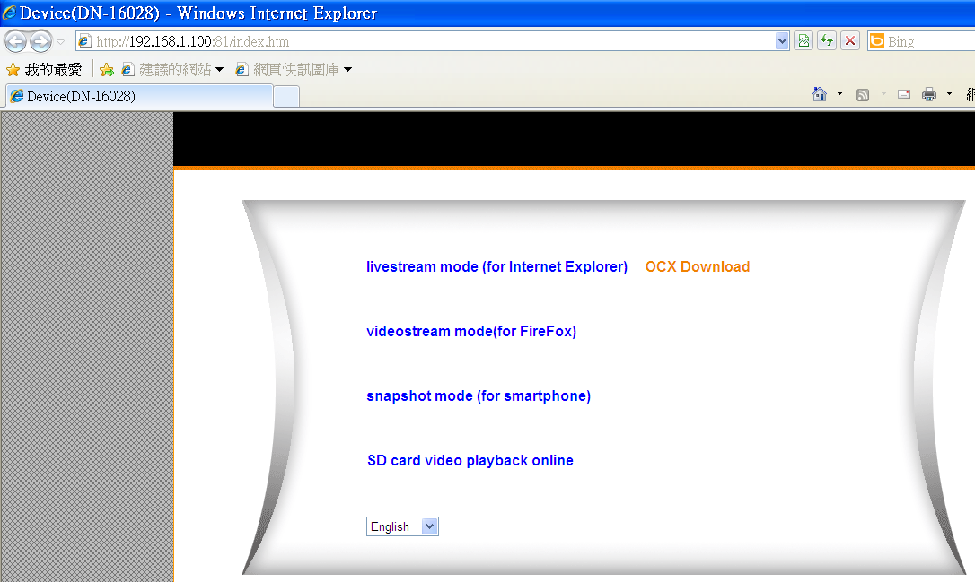

- Click the “tool” icon to get into the “Setting” page.

- Please go to “Maintain” and browse to the new firmware (64.1.0.22-only-daemon.bin) first and press “upgrade”. Please wait for 90 seconds for the camera to reboot.

After re-boot, the IP address could be changed. So please use the utility to search the new IP address again.

- Then repeat the same procedure to upgrade the other firmware file (64.1.0.22.bin).

Please note that the sequence of 64.1.0.22-only-daemon.bin first and then 64.1.0.22.bin later should be followed in this order correctly.

